NASTP Institute of Information Technology


Submitted To: Sir Hammad

Submitted By: Huzaifa Hassan

Rollno : S2025AI036

Semester: 4th Semester – Fall 2026

Subject: ML LAB

1. OBJECTIVE
To implement core Python programming logic using conditional statements (if/elif/else), bounded and event-driven loops (for, while), modular functions, and composite data structures (lists of dictionaries) to solve real-world automation, data filtering, and aggregation problems.
2. THEORY
- Conditional Branching: Evaluates Boolean expressions sequentially. elif executes mutually exclusive conditions, preventing unnecessary downstream evaluation once a condition evaluates to True.
- Loop Controls:
  - for loops iterate over a predetermined sequence (e.g., range(3)).
  - while loops repeat until an invariant condition becomes False.
  - break forces early loop termination upon meeting exit criteria.
- Modular Functions: Encapsulate reusable logic using the def keyword, accepting inputs via parameters and passing processed values back via the return statement.
- Composite Data Structures (List of Dictionaries): A primary pattern in data manipulation where each list entry represents an entity/record, and inner dictionary keys map to entity attributes/features.
- Key Aggregation Formulas:
  - Arithmetic Mean:
$$\overline{x}=\frac{\sum_{i=1}^{n}{x_{i}}}{n}$$
  - Metric Thresholding: Mapping continuous numerical ranges into discrete categorical classes (status/grades).
3. TOOLS / SOFTWARE / LIBRARIES
- Operating Environment: Jupyter Notebook / Python Interactive Environment
- Language: Python 3.x
- Libraries: Python Standard Built-ins

4. PROCEDURE / METHODOLOGY
- Task 1 (Smart Thermostat): Took numerical temperature input and categorized operating states using multi-way conditional checks (> 30, 15 to 30, < 15).
- Task 2 (Login Attempt Limiter): Constructed a bounded retry mechanism with a for loop, tracking failed attempts and halting on either successful password verification or account lock after 3 unsuccessful attempts.
- Task 3 (Discount Calculator): Designed a parameterized function apply_discount(prices) that iterates over a list of prices, applies conditional discount multipliers ($0.80$ for prices $>100$, $0.95$ otherwise), and returns a transformed list.
- Task 4 (Inventory Management): Mapped inventory stock using key-value pairs in a dictionary. Iterated over the dictionary to flag items below safety thresholds ($<5$) and aggregated total stock.
- Task 5 (Student Records Analysis): Stored tabular student data using a list of dictionaries. Traversed the records to filter high scorers ($>80$), computed the cohort average, identified the top scorer, and dynamically inserted a new "grade" key into each dictionary.
- Task 6 (Grading & Analytics Pipeline): Created a composite dataset with nested numerical grade lists. Built a helper function get_average() for single-student mean computation, and an orchestration function process_class() that appended academic standing labels ("Honor Roll", "Passing", "Failing") and printed formatted reports.

5. CODE / IMPLEMENTATION
Task 1
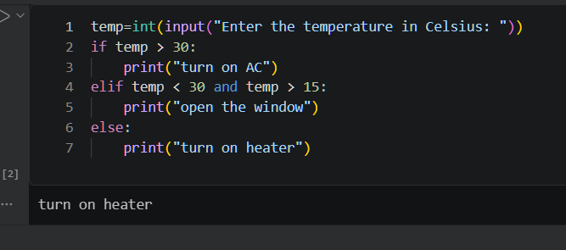

Task 2
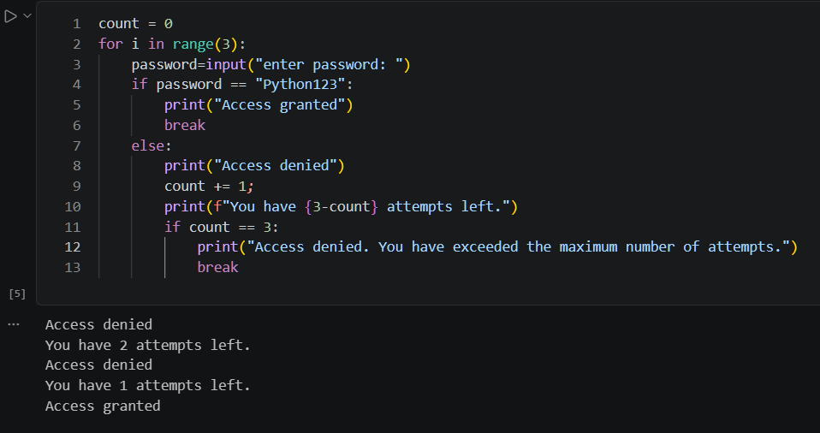

Task 3
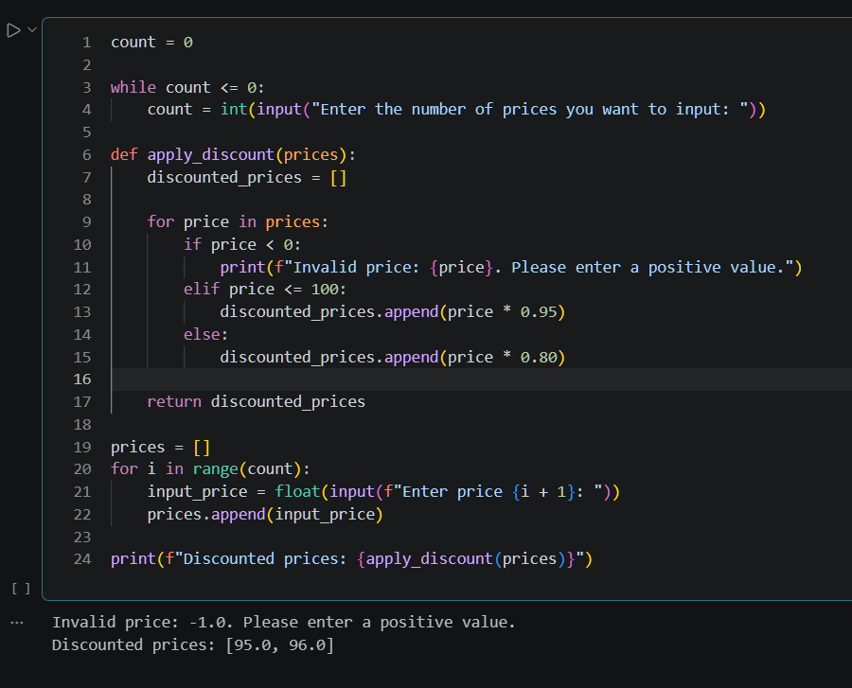

Task 4
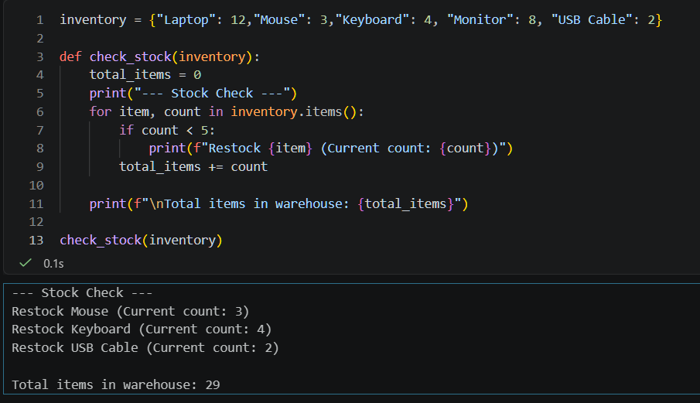

Task 5
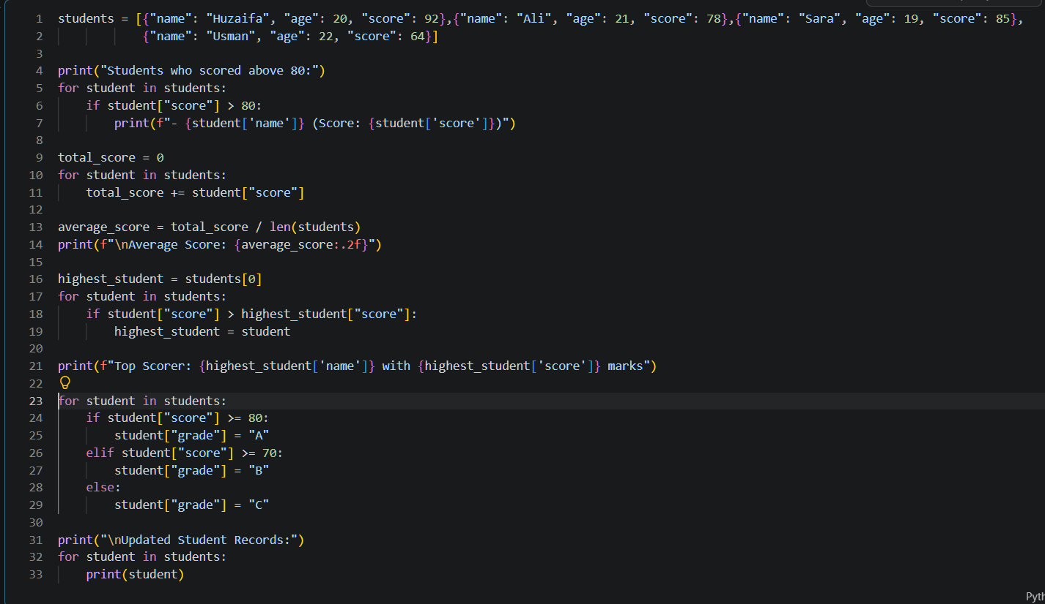
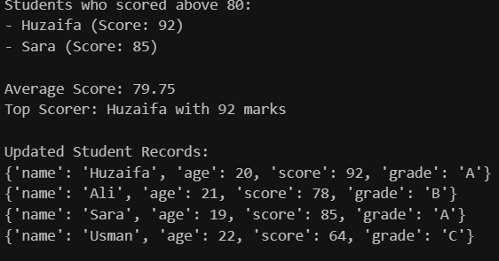

Task 6
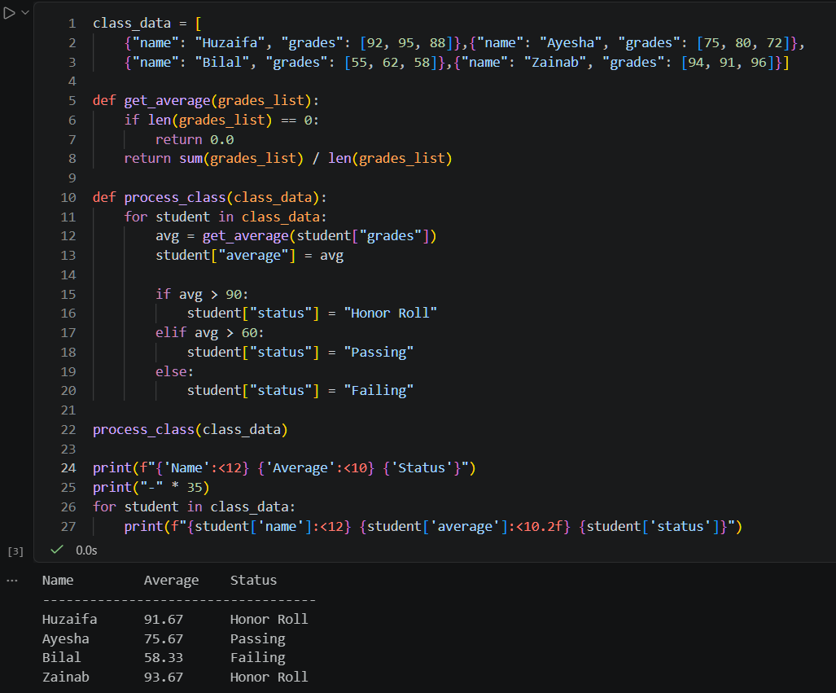

6. OBSERVATIONS
- Conditional ordering in if/elif blocks requires strict domain bounds to avoid boundary-value misclassifications.
- In-place mutation of dictionaries inside lists allows updating records directly without rebuilding the entire data structure.
- Decoupling mathematical computation (such as get_average) from higher-level iterative logic (such as process_class) improves modularity and mirrors practical data preprocessing pipelines in Machine Learning.
7. ANALYSIS / DISCUSSION
- Input Validation & Safety: Loop-driven validation (as used in the price input routine) prevents downstream runtime errors by blocking zero or negative lengths prior to list iteration.
- Data Organization: Moving from flat parallel lists (Lab 1) to lists of dictionaries (Lab 2) significantly improves data integrity: each entity's attributes stay encapsulated within a single object, avoiding index desynchronization during sorting or filtering.
8. CONCLUSION
Core algorithmic structures—including nested decision trees, bounded loop counters, custom functions, and nested dictionary structures—were implemented and verified. The exercises demonstrated how procedural logic directly translates to data validation and feature categorization workflows essential for machine learning data preparation.

